Choosing to Serve God
July 11th, 2021

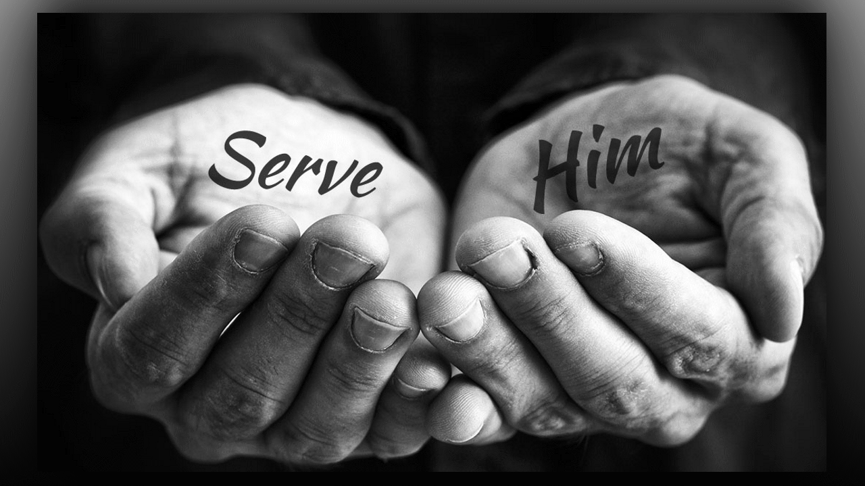
May the priceless treasure of Jesus keep your heart from the world. Amen.
Well heart dwellers, recently a very dedicated young lady left the world to follow the Lord here at the refuge. She is called to Ghana as a missionary and the Lord brought her here for preparation. She had been in an engagement to a good man, but knew that God was calling her to the Refuge in preparation for Ghana. I will give them both anonymous names to protect their privacy. Jesus brought Eric and Lilly together, they met and fell in love. They were making plans for a wedding when things just didn't feel right. There was contention and misunderstanding between them, all of a sudden, Lily felt God calling her apart for a season here at the Refuge. However, she still held onto a prophetic word that Erik and she had a future together in Ghana.
Time passed, Lilly was growing in holiness and learning more about herself, and he was dating other women, not really satisfied with any of them as far as marriage goes. Erik was a career man but had a big heart for the poor and wanted to subsidize missions to his people. There were things about our faith that he did not agree with, and we have been communicating, because there are misunderstandings about certain things. In any case, Erik is in the world and really didn't understand why Lily wanted to live a life of Evangelical simplicity and also as a Franciscan sister. Erik still cared for her and was planning a trip to visit her in America, but was still really questioning the whole thing. So, Mother Clare wrote him a letter to try and give him a glimpse into what God is doing with Lilly, so he would understand it is a good thing.
Dearest Erik, you are on my heart every day and I long to share with you the great beauty of our lives up here in the wilderness. I know it seems irrational to live this way, free from earthly striving, praying for hours, reading the Scriptures and holy books, like the Imitation of Christ, which I highly recommend to you.
I know it seems foolish, but there is a piece of the puzzle, in fact many pieces of the puzzle that you just haven’t experienced yet. Dearest, I am in love with Jesus, I have given Him my life and I only want to serve Him. I have had everything the world wants and I found it lacking because I did not have that intimacy with Him.
Even as an Evangelical Christian for 8 years, I felt something was really missing in the way the church lives. I wanted a vibrant, intimate and fulfilling relationship with Jesus, not the half-baked thing that I had with one foot in the world and one striving for Heaven. When I finally realized that I needed to give up all the world holds dear, and make His agenda, which is to save souls, to make it my agenda with His grace, I found my happiness.
No more struggling with “looking good,” driving a nice car, having all the world’s approval and houses, those things became really empty to me. When I gave it all up, He showed up in My life as though I was living in the first century, walking with Him and bringing Him to others. My spiritual life went from mediocre to exploding with life, meaning and satisfaction.
Dear one, He gave up everything for us, how can I hold back anything for myself. When I do, I am never happy with it, I always want more or better, the wants never end. But when I said, “Enough! Lord, I only want you and the fullness of your presence in my life." When I did that, my life went from ho-hum to exciting, vibrant and joyful. Eric, I truly found the pearl of great price and I didn’t want anything the world had to offer.
I had tried to live a compromised life in the Christian community, but the world was so strong, competition, jealousy, favoritism, politicking, always trying to gain favor in the world’s eyes, all of that was rife in the church. I didn’t want that anymore. I just wanted JESUS. No posturing, no impressing others, no more living for what my friends wanted me to be. I had found the Pearl of Great price and nothing from the world had any meaning for me.
That’s why I chose this life dear one. It is a life of Evangelical simplicity, where I have all the time in the world to pray and help others, and am not tied to anyone’s agenda but My Lord’s. No shopping for clothes, no impressing the public, no posturing for position, just plain, simple living for the Lord and what He wants me to do every day.
I realized that He knew much better than I where the harvest fields were and all I had to do is follow His instructions. And how good God has been to me, now I am teaching others how to hear His voice and give up our selfish lifestyles to serve Him. I have never been happier in my life. I am deeply satisfied with what He has done since I handed over all my life choices to Him.
Eric, He knows the cry of your heart dear one. He knows the tenderness and love you have for the lost. He knows these things because He created you for this. Something priceless, a true treasure, one of a kind, has been given you in your heart. He knew you before you were born and set you apart to live an extraordinary life of holiness. I don’t mean what you wear, I mean what’s in your heart, how you spend your time, your priorities. He longs to bless you beyond your wildest dreams because He knows you will do so much good with what He gives you.
Beloved, there is only one thing He asks of you, and that’s your abandonment into His will. He leads us by what is going on in our hearts, because He sits on a throne in your heart and He is the one that quickens you.
“The King's heart is in the hand of the LORD, like the rivers of water; He turns it wherever He wishes.” Proverbs 21:1
He speaks to you in the secret recesses of your heart and brings you dreams of what could be. Our only task is to TRUST Him, that He knows what He is doing, where you are going, who you will need by your side, and how He wants to lay the ground work and prepare you for your life. He knows how you will end your life, whether it will be swallowed up in regrets or "should have done" or if you will hear the words, "Well done My good and faithful servant, come enter into your Master's joy." He knows the number of your days, Eric, and that your destiny is in Heaven with Him. He guards you as the apple of His eye and directs you if you are willing. He is not thinking as man thinks, He is God and is looking at the big picture.
I’m sure you’ve seen skyscrapers going up, first they dig down several stories to anchor the beams and foundation. The taller the building, the deeper they must go to ground it. Lilly has a very special mission that requires very special preparation. The Lord brought her here to do battle with her flesh, her attitudes, her understanding of humility and human nature. We don’t have a curriculum; the Holy Spirit arranges the lessons Eric. Every day He brings situations that reveal more about ourselves so we can be in control of our selfish human nature. In order to serve the Lord, great preparation is required. Some of it can be done in the world, other parts must be done in a very pure environment. That is what the Lord prepared for her here.
The world is full of distractions, impurity, immorality, temptations and side tracks, so much precious time is wasted in foolish pursuits. That is why He calls us to a place set apart…a desert if you will…"I will allure her and lead her to the wilderness, and speak to her tenderly." Hosea 2:14
In this pure desert environment she is purified. Her motives are examined and brought into line with her true purpose. The attitudes that have hampered her in the past are slowly and gently exposed and done away with. The restlessness and pride that afflict so many of us is removed so that the soul can come to grips with their very purest self, where God speaks to them and guides them.
Here she learns to yield, to respect, to obey, to set her sights on Heavenly matters and the salvation of souls, not on what moth and rust corrode, and those things we will be ashamed of at the end of our lives. Women coming from the world have a wild and proud nature that is not pleasing to the Lord and does not make for a good marriage. I should know, I was the very worst in many ways. But the Lord tempered me, He revealed my pride, He broke me, several times, and yet, He invited me into the sweetest and most rewarding life any soul can have, intimacy with Him in absolute purity. The sweetness of God swallowed me up and left me rejecting the things in my nature that were corrupt. His love conquered my wildness, His tenderness drew me deeper and deeper into His Heart and will for my life.
When a man decides that he wants to become a surgeon, he goes through miles and miles of studies, observing surgeries, learning the art of healing. All of this is done in a very controlled environment, the hospital and university theater. It takes a very special practice and discipline to turn out a doctor and a surgeon.
When we come to serve the Lord, an even higher calling than a doctor, He brings us into the environment that will best serve His purposes to prepare that person to become a doctor of souls. That is why Lilly is here, she is becoming a doctor of souls. And the very first parts of the lesson plan are discovering our deepest selves, who we are and who we are not. With this knowledge, we can go forward and learn about others, how to love them, how to help them, how to serve them.
So, you see the whole entire purpose of her responding to God's call with a "Yes" is to prepare her to go out into the world and bring Jesus to the people. She did not design her lesson plan, she followed her heart, where Jesus was calling her. She had no idea what it would be like up here, but she was confident because Jesus told her to come. This is what Divine Providence is all about, having complete and total faith in God's ability to raise us up. We do not search for the best school; we follow our hearts and our obedience brings us into the very best environment for us to grow in. If it were possible for her to learn the same things out in the world, the Lord would have chosen that for her. But He knew what she needed and she said "Yes" to Him.
That's all we are about...just saying yes...doing what He asks us to do...not worrying about the result, He's got that part down...just being meek, humble, teachable and willing. In the end she will be the woman of God He has called her to be, because she did not take her life into her own hands and reasoning, she gave it all to God and let Him make her choices.
Dearest Eric, I hope you understand, God is doing something very special with her and with you...if you are willing. Please, if I may admonish you, Satan will use worldly women to corrupt you, they have their own agendas with you. More than anything else, you need to isolate yourself from their influence and seek God alone, for He is pure and has only your best interests at heart, where women tend to place designs on men they are attracted to. And if they are not living for God alone, they will not understand Lilly's choices.
King David was a holy man, but even he fell under the influence of a woman, Bathsheba for whom he was willing to commit murder. Later his son Solomon also fell because of women.
I Kings 4:29 and 30, “And God gave Solomon wisdom, exceedingly deep insight, and understanding beyond measure, like the sand on the seashore. Solomon’s wisdom was greater than that of all the men of the East, greater than all the wisdom of Egypt. Women seduced him into following other gods. His heart was led astray and no longer completely belonged to the Eternal One, his True God, as his father David’s heart did. Solomon pursued Ashtoreth (the Sidonian goddess) and Milcom (the abomination of the Ammonites). Solomon abandoned his lifelong integrity and committed evil in the eyes of the Eternal. He did not follow Him completely, as his father David had.”
I Kings 11
Even if you feel that you are braver than David and wiser than Solomon, please avoid every occasion of sin and cleave to the Lord, lest you lose the high calling on your life. Worldly women will lead you astray and Satan will steal the most precious treasure God wants to entrust to you.
Praying for you.

Love, Mother Clare

